Git and Git-Hub-01
- Watch the video and write notes – Notes have been drafted for future references.
- Create a GitHub account – Account created and added to favourites.
- Set up MFA (Multi-Factor Authentication) for the GitHub account using a mobile app – MFA set up is complete and added to mobile app via Authenticator app.
- Execute all commands shown in the video – All commands have been executed and evidences have been attached in this word document.

Introduction
Git is a distributed version control tool.
Git Hub is a Centralized repository or source code management tool to store the source codes.
In Git, we have two version controls,
1 is Centralized Version Control
2 is Distributed Version Control

- When Git bash is installed, Git will also be installed. To verify, command- git –version. If the Git is not installed, command- yum install Git/ apt install Git according to software.
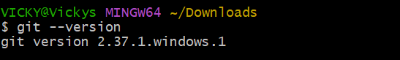

- Here, we have initialized git by using command- git init.
Now, git has created a repository in my local machine.
Verified the hidden file under the project by using ls -a, where we have a file- dockerfile.
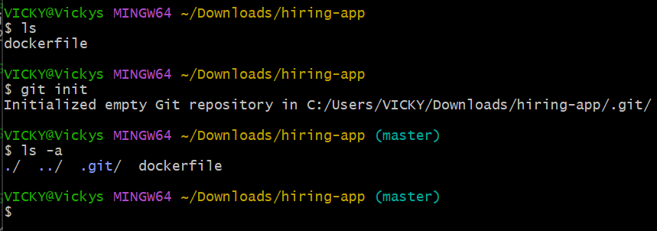
- .git is very important directory and without this directory, git will not work to track changes.
Cd .git to know the configuration installed in git.
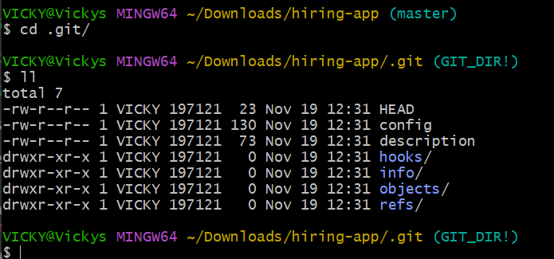

- By verifying “git status”, we got some comments.
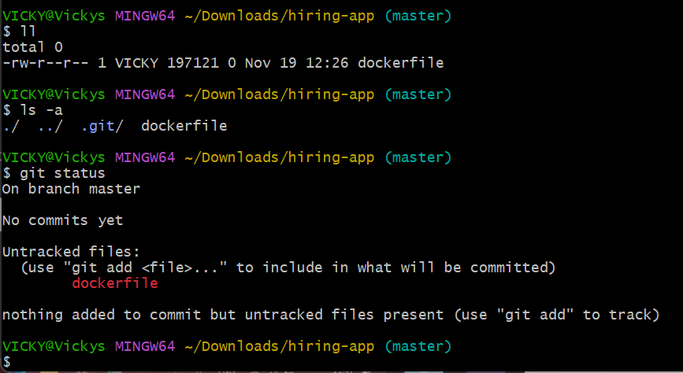

- Now we created a file called “touch a”, we verified using command- git status and see the tracking is on and we have “a” file created.
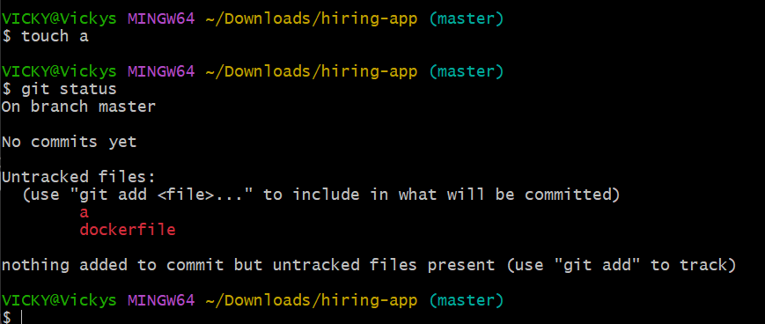

- To config “Name” and “Email”, use command “git config --global user.name “Name”” and similarly for email “git config – -global user.email “email””.
Then verify if added using command- “git.config --list”
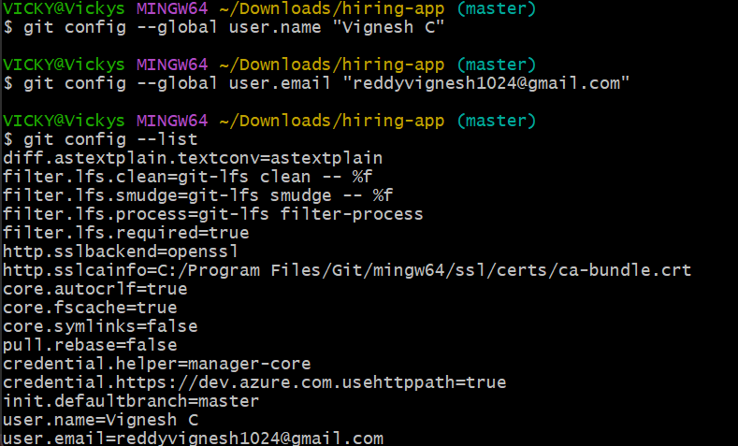

- To add the file from untracking area to tracking area. Use command- “git add” and add the file names. Now the files have been added from untracking to tracking area.
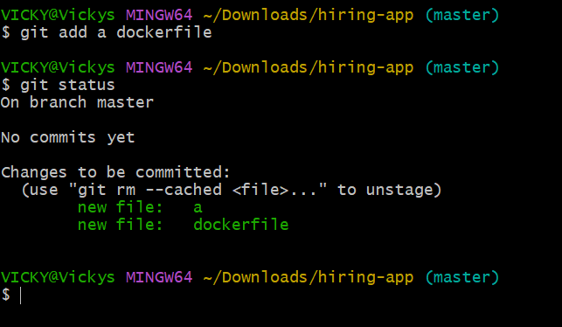
- To add all the files to tracking area at once. Then use command- git add . , then all files will be moved to tracking area.
Now all the files have been moved to tracking area.
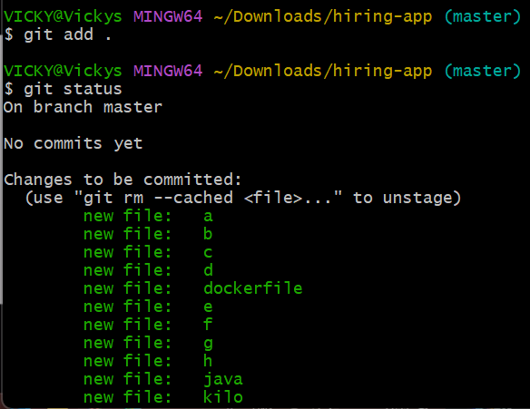
- To commit files in the tracking area, use command- git commit -m “message”.
-m means adding a message to the working people to understand how we are developing the project.
Now all the files have been committed and status says “working tree clean”.
No we are ready to push the codes/files to the central repository.
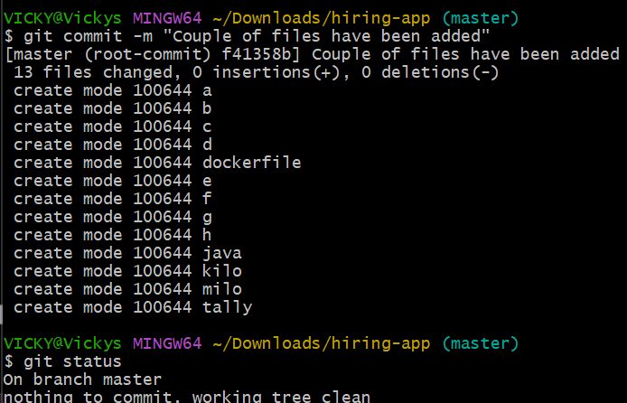
- Below is the commit ID, where we need to know this id, to make sure what are
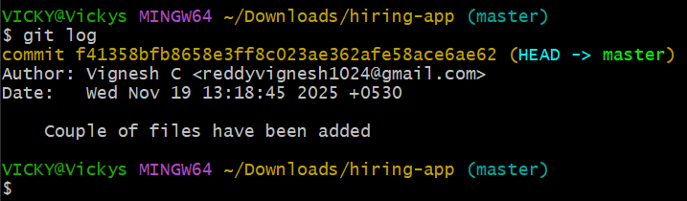

- If there are addition codes/files added to the previous additions, follow the same process- touch git addgit statusgit commit -m “message”git log.
A new unique commit ID will be updated whenever a new code/file have been added using touch command.
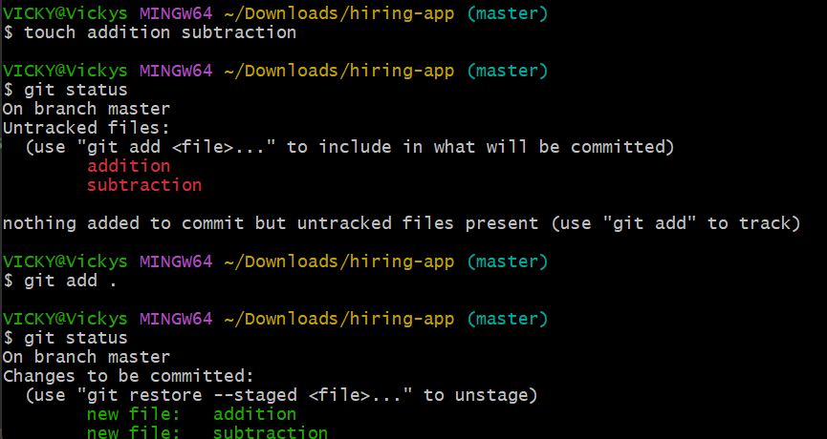
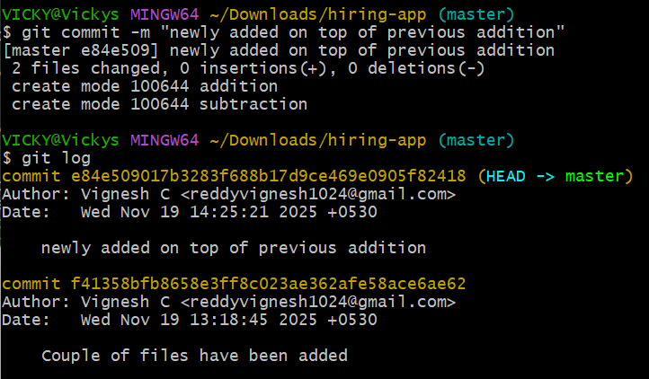

Create a GitHub account

Account created and added to favorites in browser
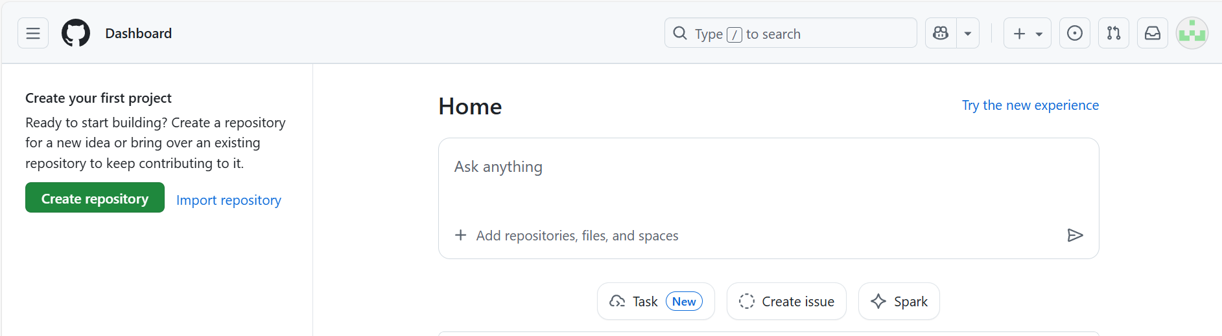

Set up MFA (Multi-Factor Authentication) for the GitHub account using a mobile app
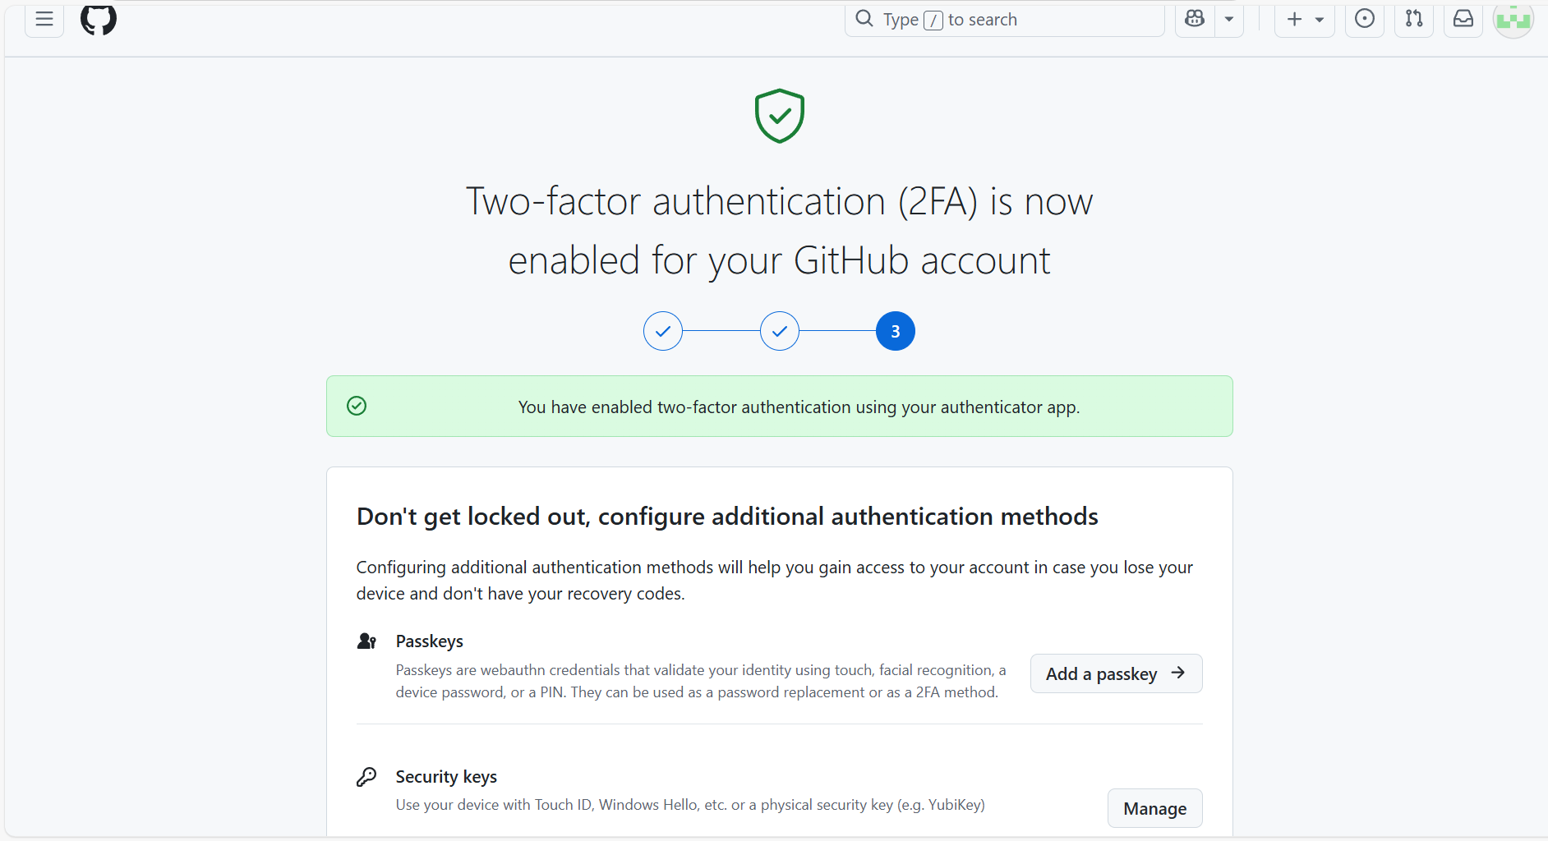

- Now last step is to push the codes to central repository, that’s git push.
But there was a error, where we need to provide location where the codes need to be sent.
We need to know Origin, so we need to create a repository in GitHub a new repository is created in GitHub named- Techie-horizon-16.
The origin code will be available in repository itself.
To verify if the origin is added to Git then command- git remote -v
Now the origin is added.
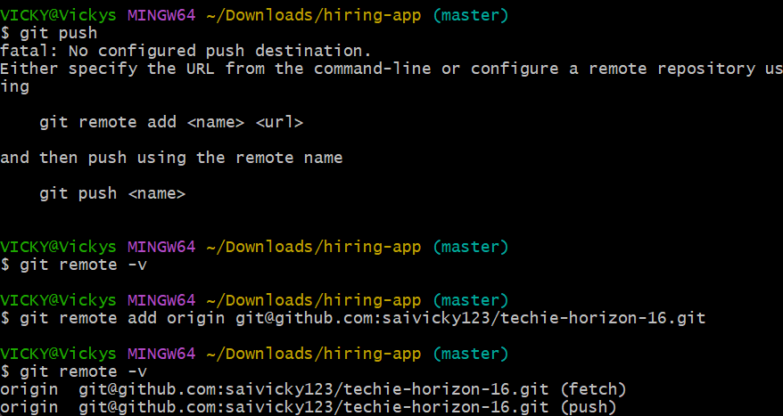
- When I tried to push the codes, I received an error saying permission denied.
Now, we need to provide permissions.
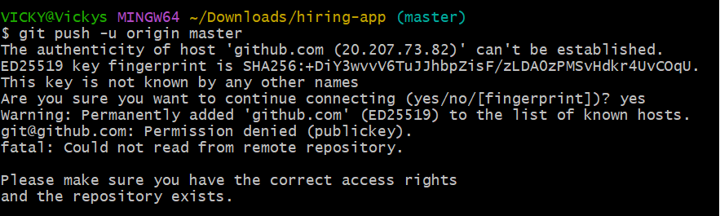

- Using ssh-keygen command, we created a public key.
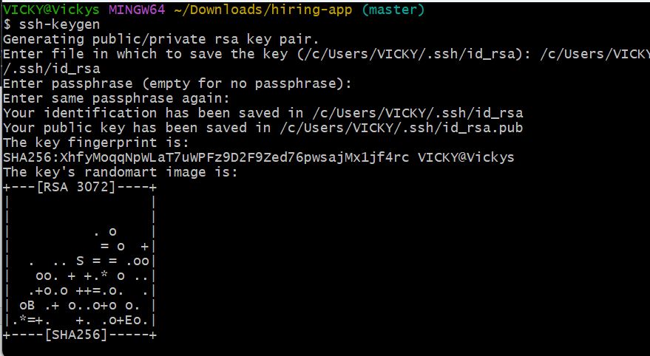
- Using CAT and public key .ssh from the ssh-keygen, we will create a ssh key, where the below key should be posted to the GitHub SSH keys by creating a new one.
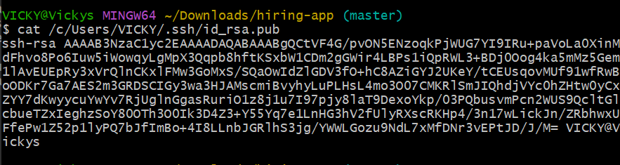

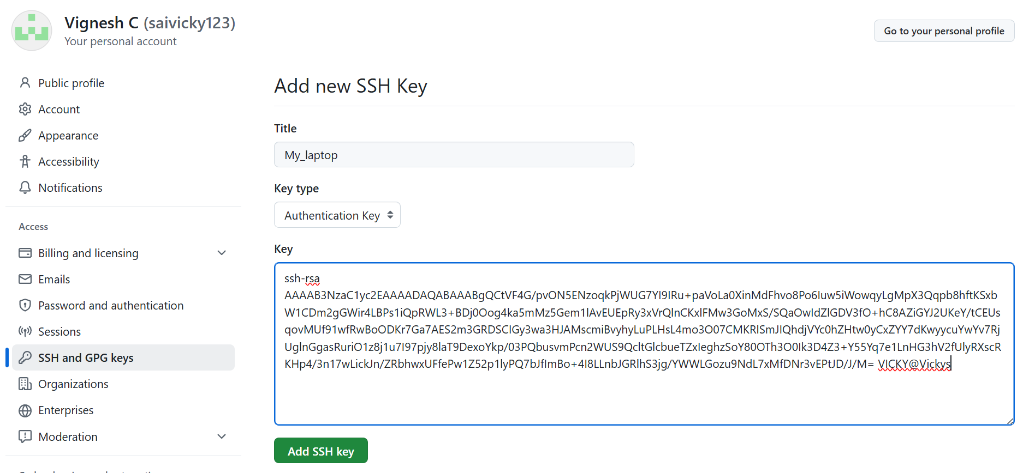
- Now a new SSH key has been created.
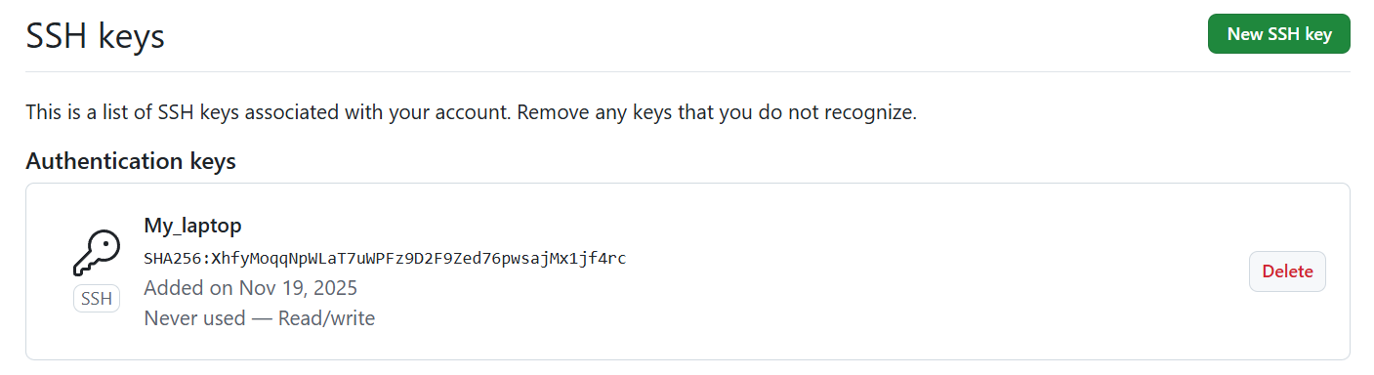
- Now, we can push the codes to GitHub by using command- git push -u origin master
Success, now all codes are sent to GitHub
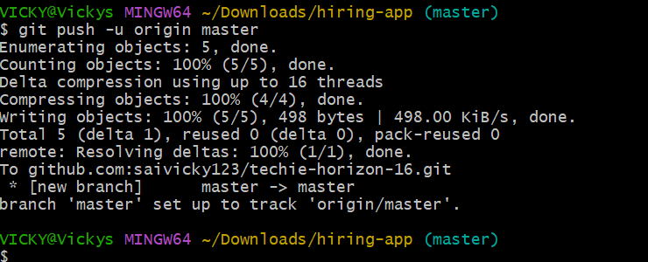
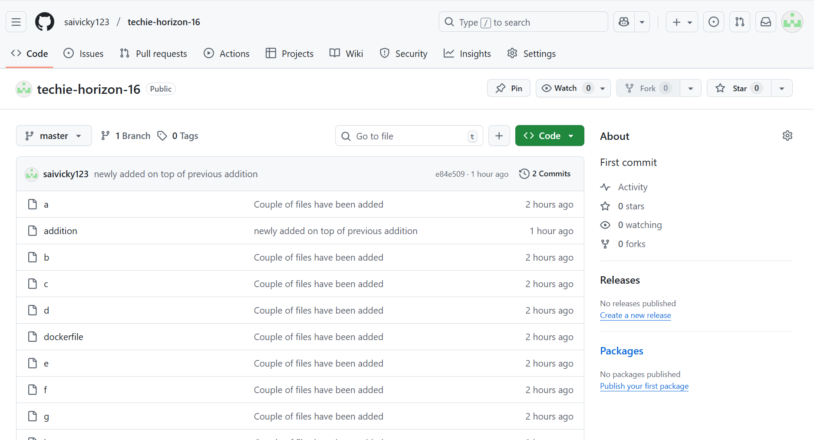

- If we want to share the working repository with someone or our team, then using the link, share it.
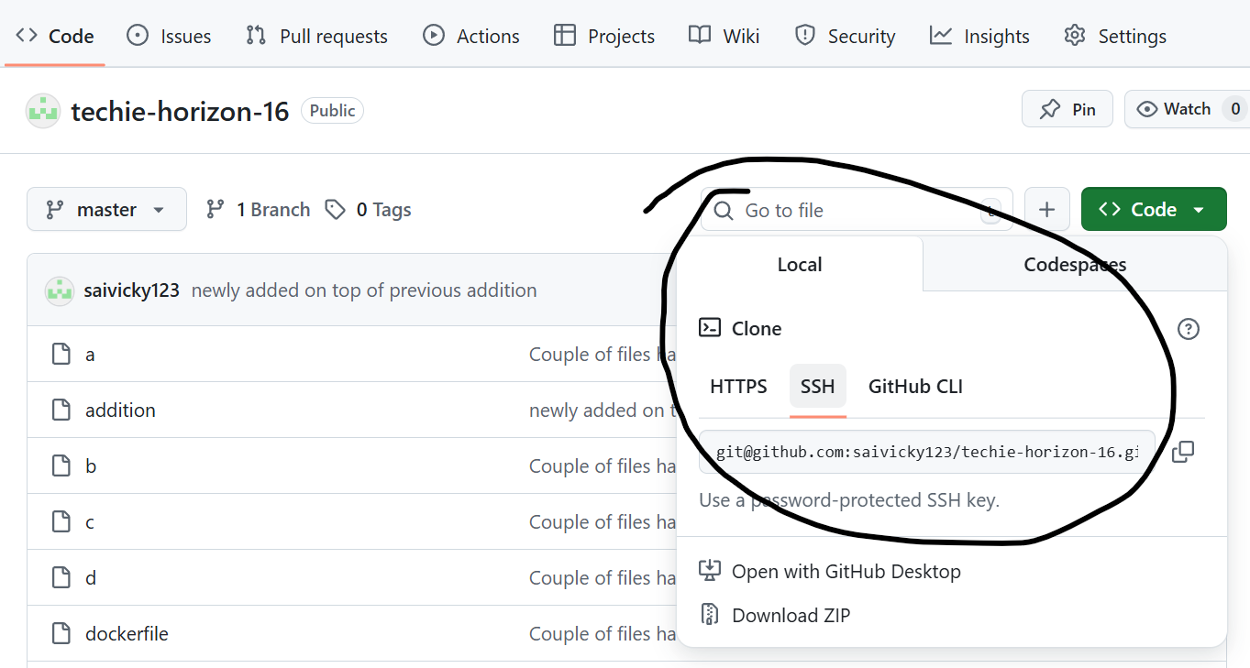

- Now, we deleted a code from local machine using rm filename
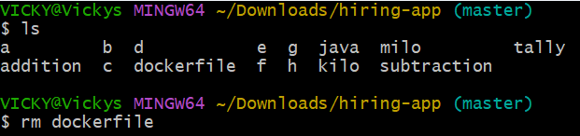
- Using git add . we modified the code and the commit the code using command- git commit -m “message”
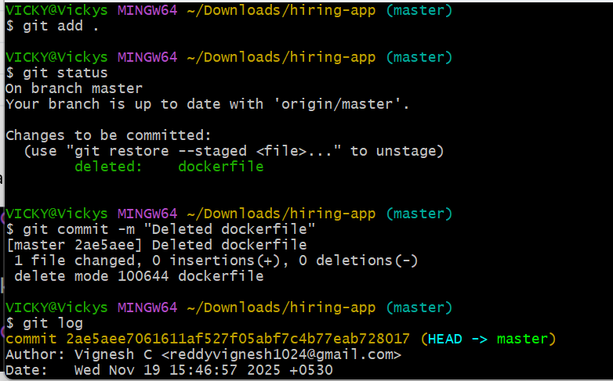
- Now, we can push the code to GitHub using command- git push -u origin master and refresh the GitHub.
- Success- code is removed.
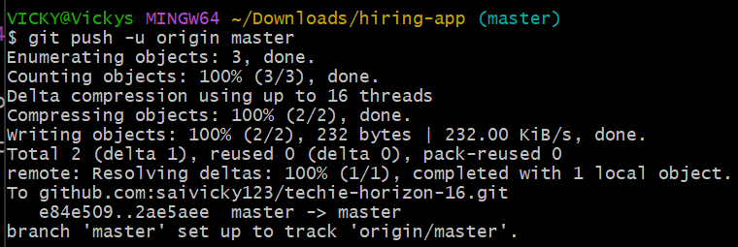

I created a new file and want to push to the GitHub.
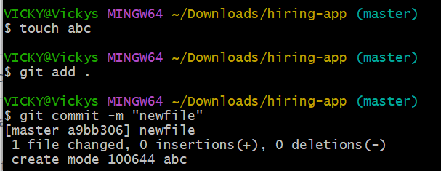
While pushing the new file to GitHub, received an error due to the file when someone made an addition directly on the central repository.
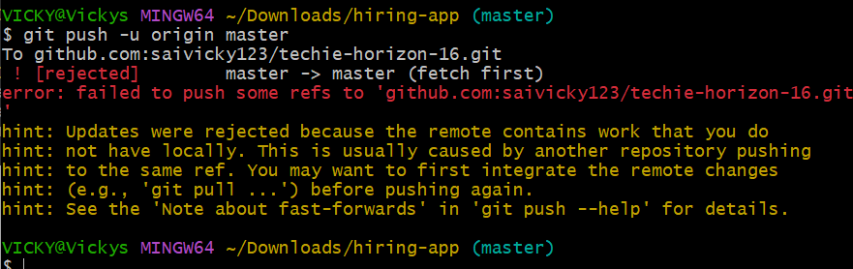
Used command- git pull to pull the repository from GitHub and pushed the newly added code to GitHub. Success.
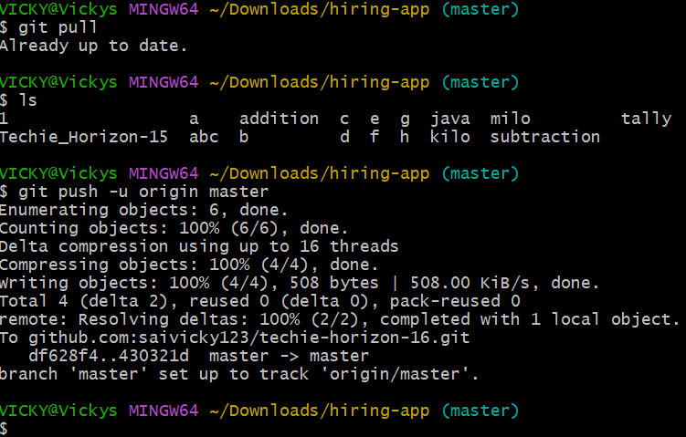
GIT Clone: Git Clone is used to get the complete repository from GitHub including the directory which we used in GitHub.
We can change the directory to the directory which was created in GitHub and view all files.
Difference between Pull and Clone: Pull is used only to get the updated changes from GitHub, whereas, Clone is to get the complete project/repository.
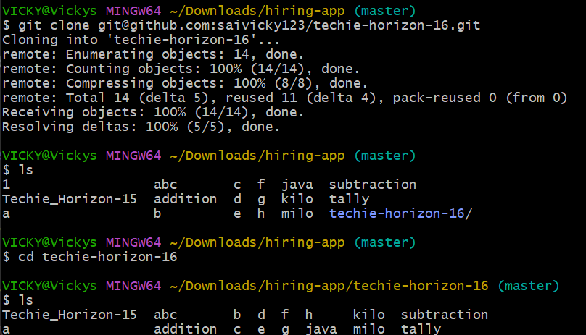

We deleted the file from local machine and emptied recycle bin as well. Now, we need to recover from the GitHub. Below is the process.
Step 1: git clone “ssh” from GitHub
Step 2: change the directory to “directory” which was created in GitHub.
Step 3: ls to verify
Step 4: To sync with GitHub, we need to add command Git remote add origin “ssh-key” from GitHub.
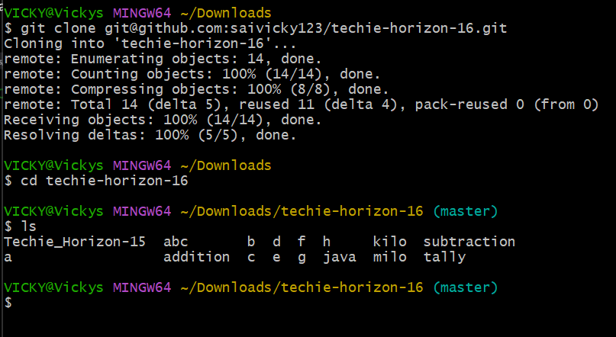

- To revert a deleted code from Git and GitHub.
Use command Git log to know the Commit number.
Then use command git revert and 6 digits of commit number from start.
Then push the code to GitHub to make changes to Central Repository – git push -u origin master.
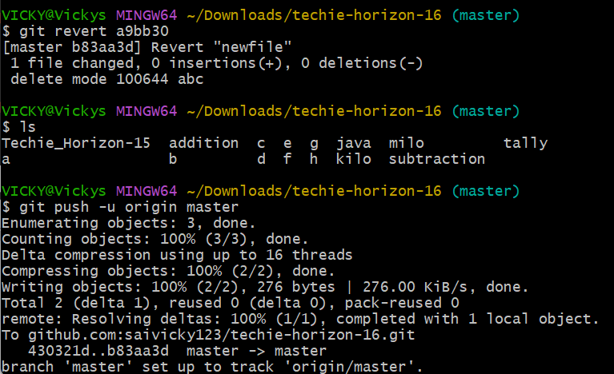

How to reset the file/code from staging area to unstagging:
- Git reset

